Spring Security Output

Login :



Login with username and password :



Succesful login ->user saerch by id



Get users table

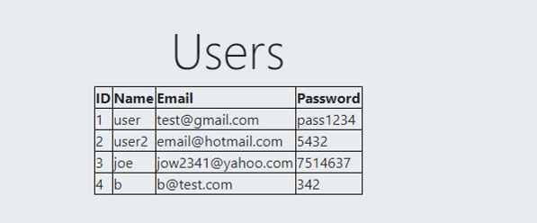

Search user with id



Fetching user dettailes and update

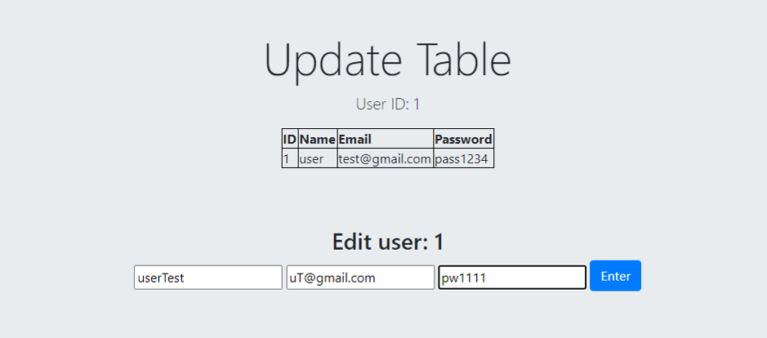

User update

